Test Case: tc002_SPX_Dev5_Crear_Requisicion_Spot_Tipo_Cobro_Project
Step 1 - Enter username and password and click to button Enter: Credentials Entered
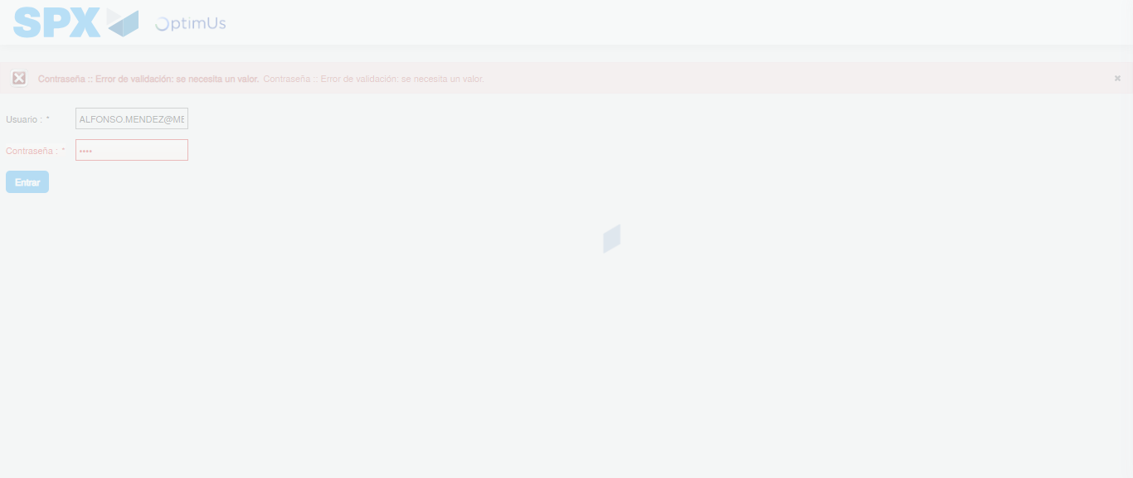Image file-name: QC_Testing-tc002_SPX_Dev5_Crear_Requisicion_Spot_Tipo_Cobro_Project-1784306906469

Step 2 - Select to UEN and Access to Spot Buy Requisitions : UEN Correctly selected and Correct access
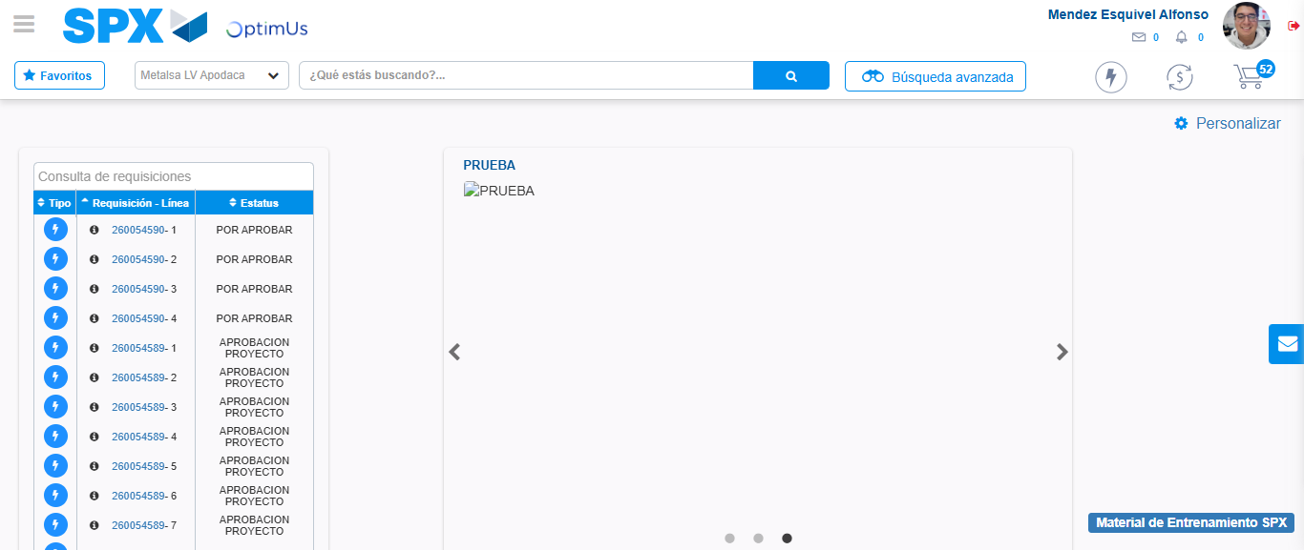Image file-name: QC_Testing-tc002_SPX_Dev5_Crear_Requisicion_Spot_Tipo_Cobro_Project-1784306943188

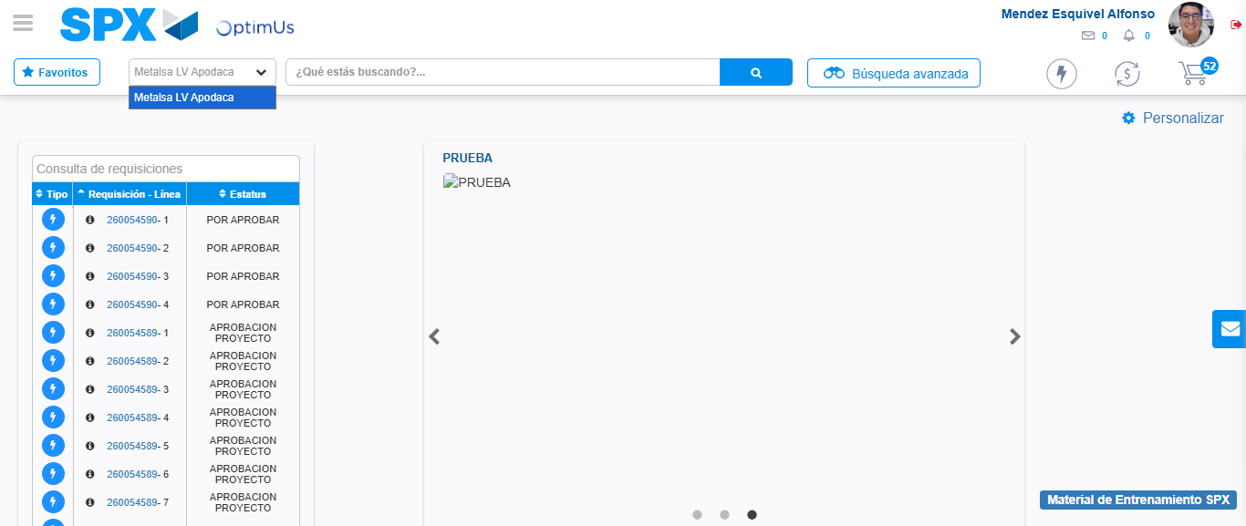Image file-name: QC_Testing-tc002_SPX_Dev5_Crear_Requisicion_Spot_Tipo_Cobro_Project-1784306945699

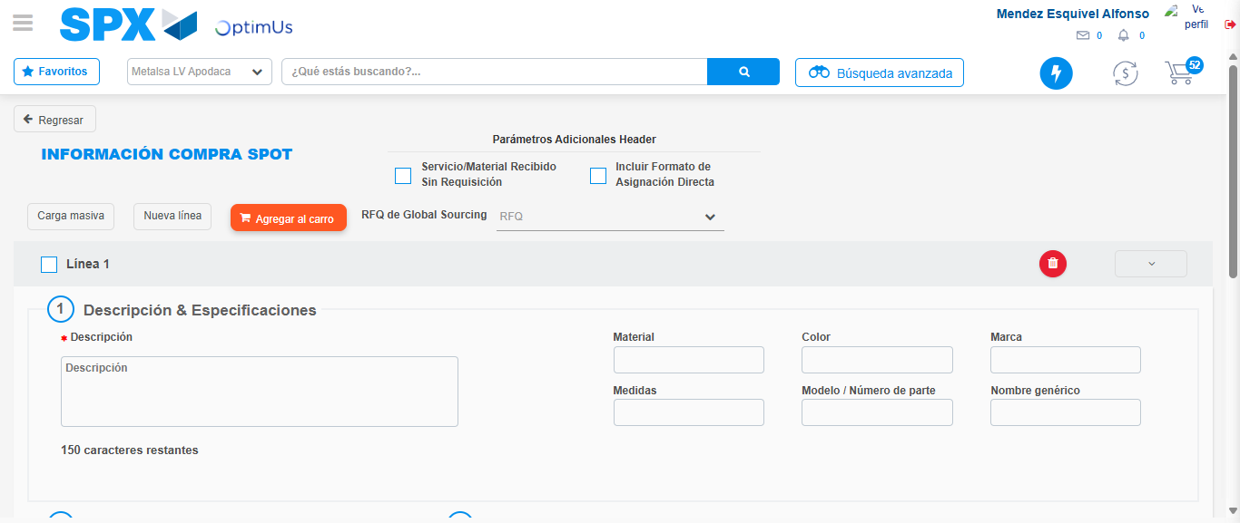Image file-name: QC_Testing-tc002_SPX_Dev5_Crear_Requisicion_Spot_Tipo_Cobro_Project-1784306957526

Step 3 - Data Capture Spot Buy Requisition: Data captured correctly
Image file-name: QC_Testing-tc002_SPX_Dev5_Crear_Requisicion_Spot_Tipo_Cobro_Project-1784306957812

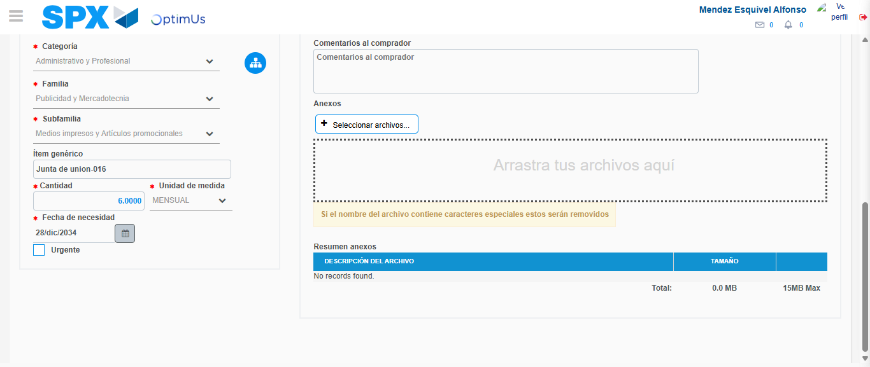Image file-name: QC_Testing-tc002_SPX_Dev5_Crear_Requisicion_Spot_Tipo_Cobro_Project-1784306969746

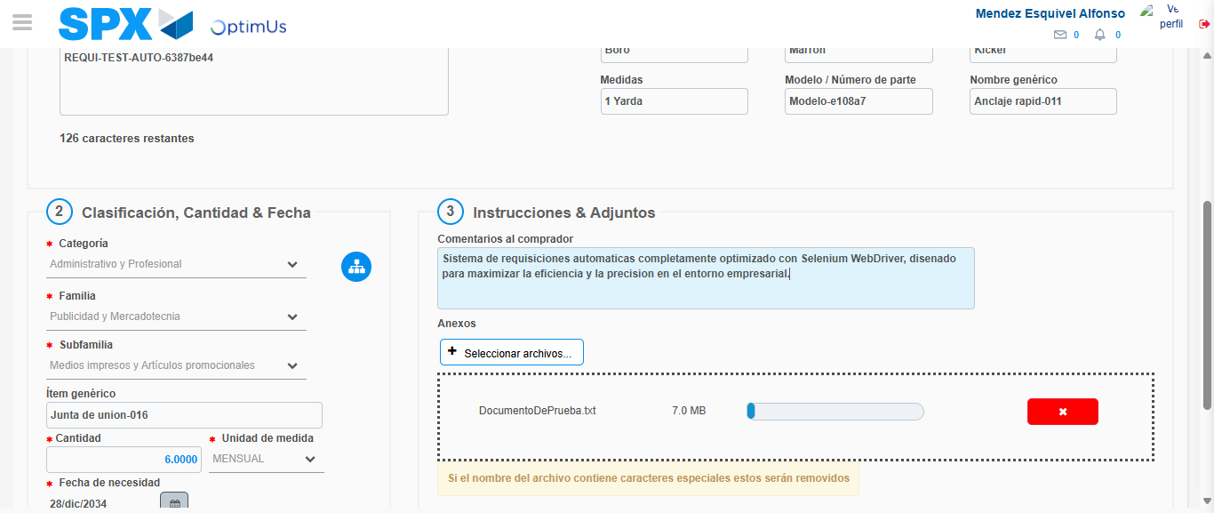Image file-name: QC_Testing-tc002_SPX_Dev5_Crear_Requisicion_Spot_Tipo_Cobro_Project-1784306970546

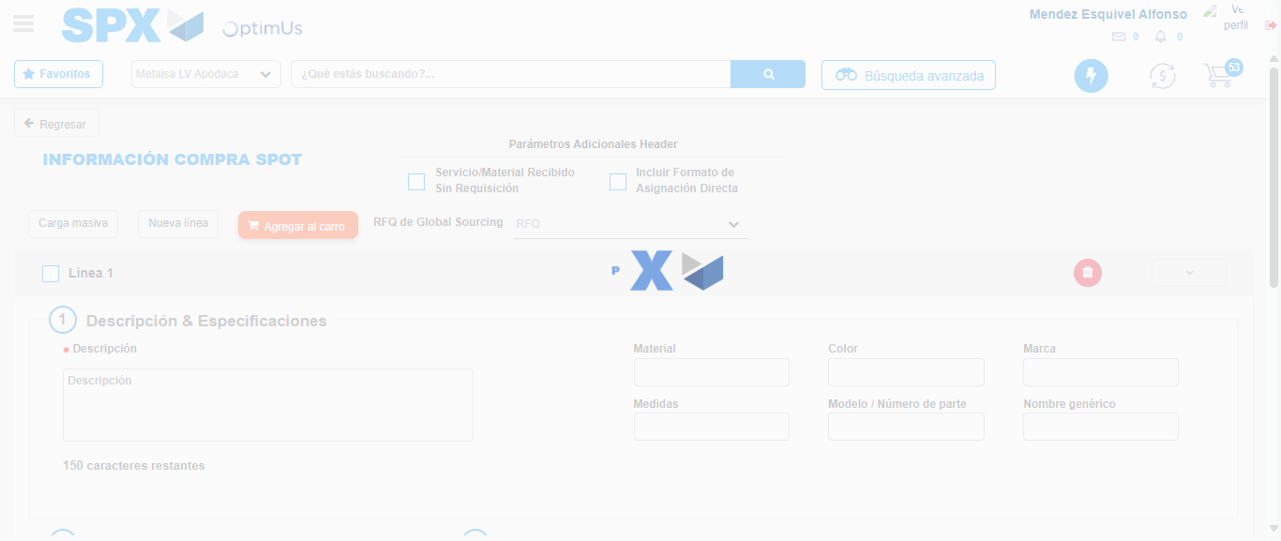Image file-name: QC_Testing-tc002_SPX_Dev5_Crear_Requisicion_Spot_Tipo_Cobro_Project-1784306976113

Step 7 - Return to Main Page SPX : Return to Main Page SPX
Image file-name: QC_Testing-tc002_SPX_Dev5_Crear_Requisicion_Spot_Tipo_Cobro_Project-1784306943188

Image file-name: QC_Testing-tc002_SPX_Dev5_Crear_Requisicion_Spot_Tipo_Cobro_Project-1784306945699

Image file-name: QC_Testing-tc002_SPX_Dev5_Crear_Requisicion_Spot_Tipo_Cobro_Project-1784306957526

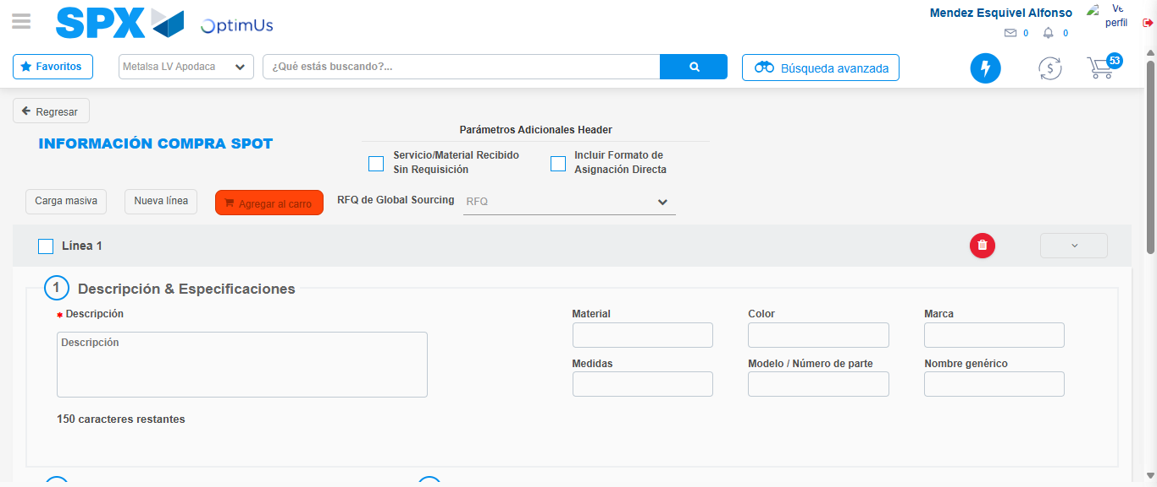Image file-name: QC_Testing-tc002_SPX_Dev5_Crear_Requisicion_Spot_Tipo_Cobro_Project-1784306978339

Image file-name: QC_Testing-tc002_SPX_Dev5_Crear_Requisicion_Spot_Tipo_Cobro_Project-1784306978539

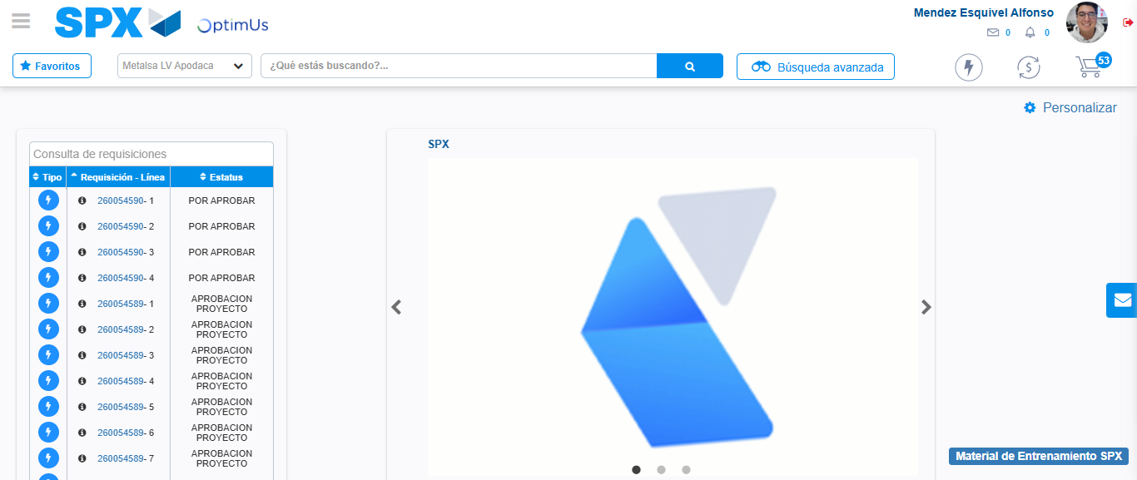Image file-name: QC_Testing-tc002_SPX_Dev5_Crear_Requisicion_Spot_Tipo_Cobro_Project-1784306999585

Step 8 - Log Out : Log Out SPX
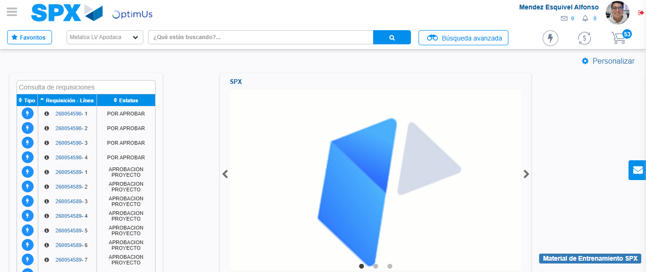Image file-name: QC_Testing-tc002_SPX_Dev5_Crear_Requisicion_Spot_Tipo_Cobro_Project-1784306999845

